Introduction
The business leaders at Big Mountain Resort have been considering a more data-driven strategy to replace their existing business strategy. They desire a better value for their tickets and are willing to enact a number of changes to make that happen. Big Mountain Resort has been reviewing a number of potential scenarios for either cutting costs or increasing revenue from ticket prices and shortlisted 4 moving forward:

- Permanently closing down up to 10 of the least used runs. This doesn't impact any other resort statistics.
- Increase the vertical drop by adding a run to a point 150 feet lower down but requiring the installation of an additional chair lift to bring skiers back up, without additional snow making coverage
- Same as number 2, but adding 2 acres of snow making cover
- Increase the longest run by 0.2 mile to boast 3.5 miles length, requiring an additional snow making coverage of 4 acres

To see how each scenario would affect the resort’s profits, we have devised a machine learning model to predict what would be the appropriate ticket price for the resort based off of data given to us by the database manager, Alesha Eisen.

Dataset
The dataset in question provides us with details on other resorts in the country, ranging from their names and location to number of assets and ticket prices. The data was ‘cleaned’ by removing resorts with missing ticket prices and dropping information about fastEight as nearly half the information was missing from the database. As for our target feature, we narrowed it to just adult weekend ticket price as there was not a need to prefer weekday over weekend prices in Montana (Table 1), thus weekday ticket prices were also dropped from our dataset.

Table 1. Adult Weekend and Weekday prices in the state of Montana
Name | Weekend Price ($) | Weekday Price ($)
Blacktail Mountain Ski Area | 42.0 | 42.0
Bridger Bowl | 63.0 | 63.0
Discovery Ski Area | 49.0 | 49.0
Great Divide | 48.0 | 48.0
Lost Trail - Powder Mtn | 46.0 | 46.0
Maverick Mountain | 39.0 | 39.0
Montana Snowbowl | 50.0 | 50.0
Red Lodge Mountain | 67.0 | 67.0
Showdown Montana | 47.0 | 47.0
Teton Pass Ski Resort | 39.0 | 39.0
Big Mountain Resort | 81.0 | 81.0

All remaining data was retained and used for our machine learning model. Exploratory data analysis suggests a number of important factors that might positively impact ticket price, including the height of the vertical drop, the number of fast Quads, the total number chair lifts, the number of runs, and the size of snow making coverage.

Modeling
To train our machine learning model, two approaches was considered: linear regression and random forest. The dataset was split 70/30 such that 70% was used for training and 30% was used for testing our models. Any values that were still missing from our dataset was fill either using their feature’s median or mean. Hyperparameters and cross validation were also utilized during the development of our model to ensure it can be generalized to test data and provide the best performance. The performance of each model is scored using the mean absolute error (MAE), which lists the error amount from our desire target price. Of the two models, random forest performed slightly better with the MAE and variance being smaller than that of linear regression ($11.79 vs. $9.54 and $1.62 vs. $1.35, respectively). The random forest model was thus saved and would be used to test the scenarios provided by the Big Mountain Resort leadership. To assess whether or not our model would require additional data for training, we plotted cross-validation scores vs. training set size (see Fig. 1).
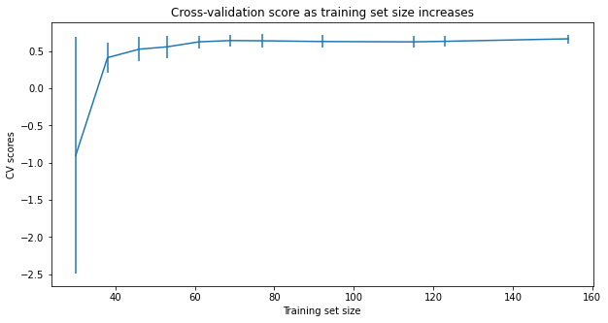
Figure 1. Cross-validation score as a function of Training set size.
As shown, performance levels off beyond a sample size of 50-60, thus additional samples would not be necessary.

Model Assessment and Recommendation
To give an unbiased assessment of our model, we refitted our model excluding data from Big Mountain Resort. Currently, Big Mountain Resort charges $81 per ticket. Without considering any changes, our model suggests that a ticket price of $95.87 would be appropriate given its existing features and facilities. Even with a MAE of $10.39, it suggests Big Mountain Resort might be undercharging its facilities by at least $4 per ticket. When considering the different scenarios provided by leadership, our model suggests Scenario 2 to be the best scenario.

While Scenario 1 could save the resort money by reducing operating costs and shutting down facilities, our model suggests we could lose support for ticket prices (hence revenue) if too many facilities were to be shut. In the best case for Scenario 1, we could save up to $1.54 million in costs by closing down one run. In Scenario 2, however, we could justify the increase in ticket price ($1.99 increase per ticket) with the added cost of facilities (~$1.54 million, assuming an additional chair lift price would be the same as previous one). The increased revenue from ticket prices (~$3.47 million) would be able to cover for the additional operating costs while bringing in profit greater than that of Scenario 1. Scenario 3 is a slightly costlier version of Scenario 2 as the 2 additional acre of snow making coverage would not make a difference in ticket price and the extra cost of making the snow makes it less ideal. In the case of Scenario 4, the change in features selected had no impact on the ticket price, thus would only cost the resort money based on our model.

